 Search Search Welcome to our online store!

[My Account](http://cms.template-help.com/magento_28842/customer/account/) [My Cart](http://cms.template-help.com/magento_28842/checkout/cart/) [Checkout](http://cms.template-help.com/magento_28842/checkout/) [Log In](http://cms.template-help.com/magento_28842/customer/account/login/) facebook.pngtwitter.gif

# **HOME ABOUT US PRODUCTS FAQ CONTACT US**

* http://cms.template-help.com/magento_28842/skin/frontend/base/theme142/images/media/slider_prev.gif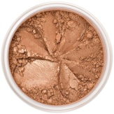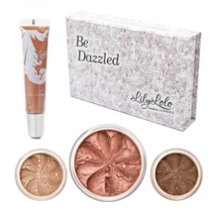[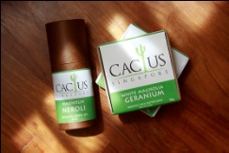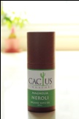](http://cms.template-help.com/magento_28842/body-care/skin-care/vichy.html/)http://cms.template-help.com/magento_28842/skin/frontend/base/theme142/images/media/slider_next.gif

|  |  |  |
| --- | --- | --- |
| [Whole](http://cms.template-help.com/magento_28842/body-care/skin-care/holiday-home.html/) Sales Learn more | [http://cms.template-help.com/magento_28842/skin/frontend/base/theme142/images/media/product_4_title_bg.gif](http://cms.template-help.com/magento_28842/body-care/skin-care/vichy.html/)[http://cms.template-help.com/magento_28842/skin/frontend/base/theme142/images/media/product_3_title_bg.gif](http://cms.template-help.com/magento_28842/diet-energy/metamucil.html/) [Charity](http://cms.template-help.com/magento_28842/body-care/skin-care/special-offer.html/) Organization world vision.gif | Free Shipping |

2010 Drugstore. All Rights Reserved.

* Terms & Conditions [Customer Service](http://cms.template-help.com/magento_28842/customer-service) [Site Map](http://cms.template-help.com/magento_28842/catalog/seo_sitemap/category/) Our Partners [Privacy](http://cms.template-help.com/magento_28842/catalogsearch/term/popular/) Policy